Project Design Phase-II
Data Flow Diagram & User Stories

Date | 13 October 2026
Team ID
Project Name | Vehicle Insurance Management
Maximum Marks | 4 Marks

Data Flow Diagrams:
A Data Flow Diagram (DFD) is a traditional visual representation of the information flows within a system. A neat and clear DFD can depict the right amount of the system requirement graphically. It shows how data enters and leaves the system, what changes the information, and where data is stored.
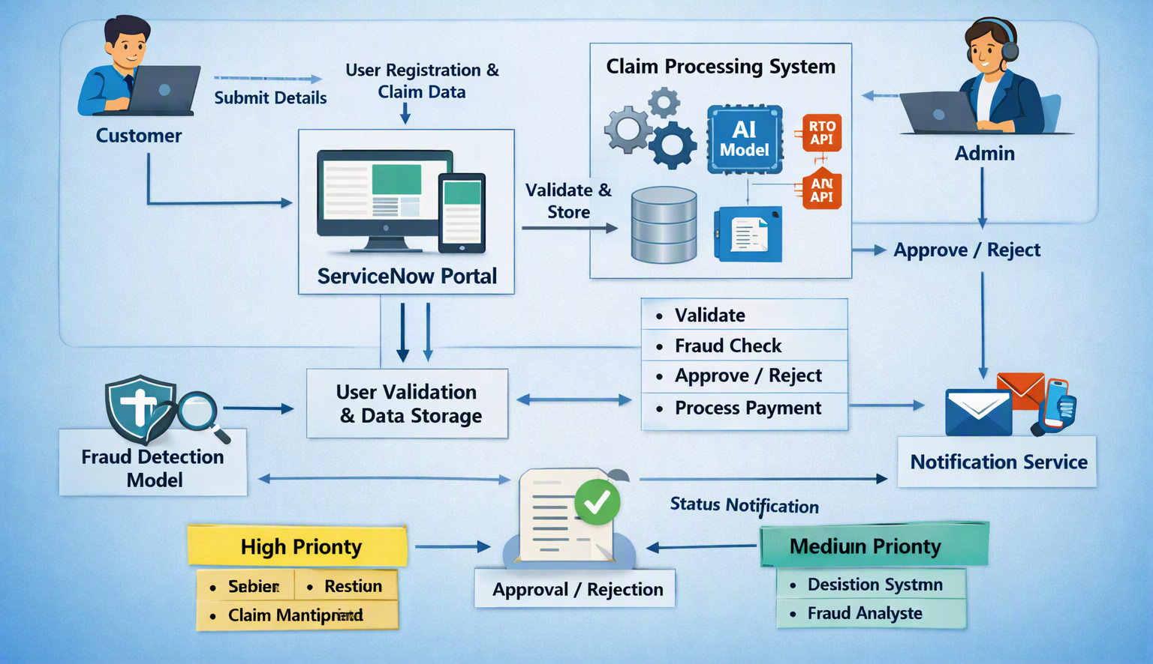

Data Flow:
- Customer submits registration or claim details via ServiceNow portal.
- Portal validates credentials and stores data in CMDB.
- Claim data is sent to the processing system for fraud detection and verification.
- External APIs (RTO, Aadhar) provide vehicle and identity validation.
- AI model analyzes claim authenticity and risk.
- Admin reviews processed claims and approves or rejects.
- Notification service sends claim status updates to the customer.
Process | Input | Output
Claim Submission | Claim form, vehicle details, accident images | Claim record created in CMDB
Validation | User credentials, policy ID | Verified claim data
Fraud Detection | Claim data, ML model | Fraud probability score
Approval/Rejection | Verified claim, fraud score | Claim decision
Payment Processing
  Approved claim
  Payment confirmation
Notification | Claim decision | Email/SMS update to user

User Stories
Use the below template to list all the user stories for the product.
User Type | Functional Requirement (Epic) | User Story Number | User Story / Task | Acceptance criteria | Priority | Release
Customer (Mobile user) | Registration | USN-1 | As a user, I can register for the application by entering my email, password, and confirming my password. | I can access my account / dashboard | High | Sprint-1
Customer (Mobile/Web) | Claim Processing | USN-2 | As a user, I will receive confirmation email once I have registered for the application | I can receive confirmation email & click confirm | High | Sprint-1
Customer (Mobile/Web) | Policy Renewal | USN-3 | As a user, I can register for the application through Facebook | I can register & access the dashboard with Facebook Login | Low | Sprint-2
Customer Care Executive | Claim Review | USN-4 | As a user, I can register for the application through Gmail | Claim verified and forwarded for approval | Medium | Sprint-1
Customer Care Executive | Login | USN-5 | As a user, I can log into the application by entering email & password |  | High | Sprint-1
Administrator | Dashboard | USN-6 | As a system, I can send automated claim updates. | Notifications delivered successfully | Medium | Sprint-2

